EXPERIMENT 11
Aim:To design a secure mobile application wireframe in Figma with Login, OTP Verification, and Fingerprint Authentication screens.
Procedure:
- Open Figma and create a new design file.
- Create three mobile frames for the authentication screens.
- Design the Login screen with username, password, and login button.
- Design the OTP Verification screen with six-digit OTP boxes and a Verify button
- Design the Fingerprint Authentication screen with a fingerprint icon and instructions
- Add suitable colors, buttons, and text to each screen
- Arrange the screens in the correct order and connect them using prototype links if required.
OUTPUT:
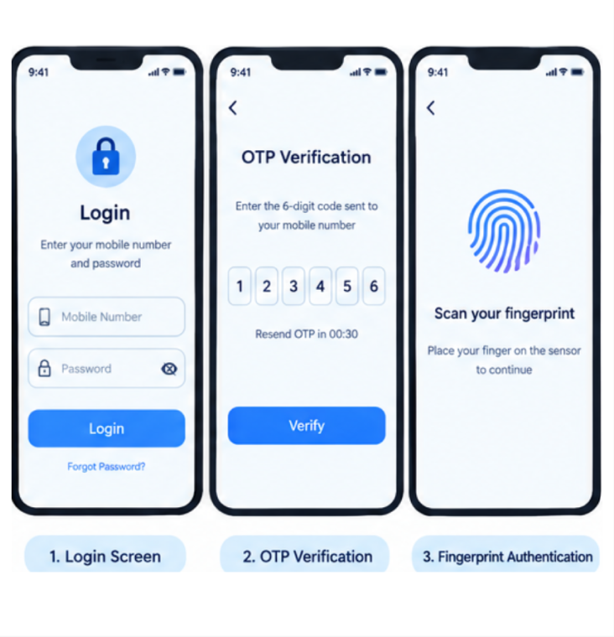

FIGMALINK: https://www.figma.com/design/ED1qcVpNfWi2Zuft4amJyZ/Untitled?node-id=62-33&t=zih8IyL283jodQsH-0

RESULT: The Secure Mobile Application Wireframe was successfully designed in Figma with Login, OTP Verification, and Fingerprint Authentication screens.

